WEBD6211 — PART 1
PROJECT PROPOSAL 2 — ETHEYS COMMUNITY CARE
Target Organisation: Non-Profit Organisation
Student Name: Ethel Muofhe
Student Number: [ST10317760]
Group: [01]
Academic Year: 2026
Academic website project — fictional organisation scenario

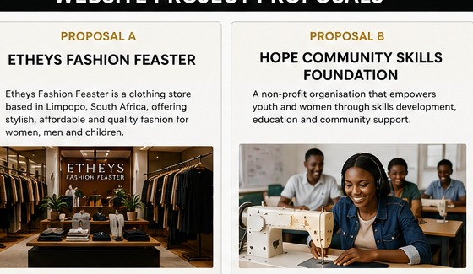
Figure 1: Concept visual for the proposed organisation. Images are documented in the image-source log.

Table of Contents
1. 1. Organisation Overview
2. 2. Website Goals and Objectives
3. 3. Current Website Analysis
4. 4. Proposed Website Features and Functionality
5. 5. Design and User Experience
6. 6. Technical Requirements
7. 7. Timeline and Milestones
8. 8. Budget
9. 9. References
Lecturer Approval

1. Organisation Overview
Etheys Community Care is a fictional community-based non-profit organisation created for this academic project. It supports vulnerable families through clothing drives, food-support initiatives, youth activities and community volunteering. The proposed website will provide trustworthy information and simple ways for community members, volunteers, donors and sponsors to become involved.

Mission and Vision
- Mission: To strengthen communities by connecting people, resources and practical support.
- Vision: A stronger, more connected community where families have access to support and opportunities.
- Target audience: Community members, volunteers, donors, local businesses and potential sponsors.

2. Website Goals and Objectives
- Explain the organisation’s purpose and programmes clearly.
- Recruit volunteers through a dedicated enquiry pathway.
- Encourage sponsorship and community support.
- Publish information about activities and programmes.
- Provide clear contact channels and accessible information.
- KPIs: page visits, volunteer/sponsor enquiries, successful navigation, mobile usability and zero broken internal links.

3. Current Website Analysis
The organisation is fictional and has no existing website in this academic scenario. A new website, therefore, provides an opportunity to establish a trustworthy identity from the start. The proposed solution focuses on clarity, credibility and calls to action rather than complex e-commerce features.

4. Proposed Website Features and Functionality
- Home page introducing the organisation and current calls to action.
- About page explaining history, mission, vision, and values.
- Services/Programs page describing community initiatives.
- Inquiry page allowing visitors to enquire about volunteering or sponsorship.
- Contact page with two proposed community locations and a map/location area.
- Consistent responsive navigation and accessible content structure.

5. Design and User Experience
The design will be welcoming and trustworthy, using high-contrast text, warm imagery, readable typography and prominent calls to action such as Volunteer and Become a Sponsor. Poppins will be used for headings and Arial/Helvetica for body text. The layout will use cards, clear sections and whitespace. Accessibility will include semantic HTML, labeled forms, alternative text, and responsive navigation. Low-fidelity wireframes are supplied with the project documentation.

6. Technical Requirements
The website will use HTML5, CSS3, and JavaScript, developed in Visual Studio Code and maintained in GitHub. A .org or .co.za domain and standard hosting could be used for a production version. The academic prototype can be hosted with GitHub Pages. Testing will include desktop, mobile and cross-browser checks.

7. Timeline and Milestones
- Week 1: research and proposal preparation.
- Week 2: approval, content sourcing, sitemap, and wireframes.
- Week 2–3: HTML/CSS implementation.
- Week 3: JavaScript form validation and navigation testing.
- Week 4: final testing, documentation, GitHub commits, and submission.

8. Budget
- Planning/UI/UX: R700
- Website development: R1,600
- Domain: R250
- Hosting: R600
- Content/testing: R250
- Maintenance allowance: R100
- Estimated project total: R3,500

9. References
- MDN Web Docs. HTML, CSS and JavaScript documentation. https://developer.mozilla.org/
- GitHub Docs. GitHub repository and version-control documentation. https://docs.github.com/
- Google Fonts. Poppins typeface. https://fonts.google.com/
- OpenStreetMap. Map data used only as a proposed location reference where applicable. https://www.openstreetmap.org/

Lecturer Approval
Approved / Not Approved (circle one): ______________________________
Lecturer comments: ______________________________________________________________
Lecturer name/signature: ______________________________ Date: _______________

